[](https://ida.interchain.io/)

[Interchain Developer Academy](https://ida.interchain.io/)/[Interchain Developer Academy](https://ida.interchain.io/ida-course/0-blockchain-basics/3-managed.html)



Search

[Interchain Developer Academy](https://ida.interchain.io/)[Interchain Developer Academy](https://ida.interchain.io/ida-course/0-blockchain-basics/3-managed.html)

Search



Filters

Interchain Developer Academy

[](https://ida.interchain.io/ida-course/0-blockchain-basics/3-managed.html)

[Week 0 - Getting Started](https://ida.interchain.io/ida-course/0-blockchain-basics/3-managed.html)

[Getting Started](https://ida.interchain.io/ida-course/0-blockchain-basics/3-managed.html)

[Blockchain 101](https://ida.interchain.io/ida-course/0-blockchain-basics/3-managed.html)

[Blockchain History](https://ida.interchain.io/ida-course/0-blockchain-basics/3-managed.html)

[Public and Managed Blockchains](https://ida.interchain.io/ida-course/0-blockchain-basics/3-managed.html)

[Consensus in Distributed Networks](https://ida.interchain.io/ida-course/0-blockchain-basics/3-managed.html)

[Cryptography](https://ida.interchain.io/ida-course/0-blockchain-basics/3-managed.html)

[Self-Assessment Quiz](https://ida.interchain.io/ida-course/0-blockchain-basics/3-managed.html)

[Go Introduction - First Steps](https://ida.interchain.io/ida-course/0-blockchain-basics/3-managed.html)

[Go Basics](https://ida.interchain.io/ida-course/0-blockchain-basics/3-managed.html)

[Go Interfaces](https://ida.interchain.io/ida-course/0-blockchain-basics/3-managed.html)

[Control Structures in Go](https://ida.interchain.io/ida-course/0-blockchain-basics/3-managed.html)

[Arrays and Slices in Go](https://ida.interchain.io/ida-course/0-blockchain-basics/3-managed.html)

[Standard Packages in Go](https://ida.interchain.io/ida-course/0-blockchain-basics/3-managed.html)

[Concurrency in Go](https://ida.interchain.io/ida-course/0-blockchain-basics/3-managed.html)

[Good-To-Know Dev Terms](https://ida.interchain.io/ida-course/0-blockchain-basics/3-managed.html)

[Docker Introduction](https://ida.interchain.io/ida-course/0-blockchain-basics/3-managed.html)

[](https://ida.interchain.io/ida-course/0-blockchain-basics/3-managed.html)

[Week 1 - Introduction to the Interchain](https://ida.interchain.io/ida-course/0-blockchain-basics/3-managed.html)

[Introduction to the Interchain](https://ida.interchain.io/ida-course/0-blockchain-basics/3-managed.html)

[Blockchain Technology and the Interchain](https://ida.interchain.io/ida-course/0-blockchain-basics/3-managed.html)

[The Interchain Ecosystem](https://ida.interchain.io/ida-course/0-blockchain-basics/3-managed.html)

[Getting ATOM and Staking It](https://ida.interchain.io/ida-course/0-blockchain-basics/3-managed.html)

[A Blockchain App Architecture](https://ida.interchain.io/ida-course/0-blockchain-basics/3-managed.html)

[Accounts](https://ida.interchain.io/ida-course/0-blockchain-basics/3-managed.html)

[Transactions](https://ida.interchain.io/ida-course/0-blockchain-basics/3-managed.html)

[Messages](https://ida.interchain.io/ida-course/0-blockchain-basics/3-managed.html)

[Modules](https://ida.interchain.io/ida-course/0-blockchain-basics/3-managed.html)

[Protobuf](https://ida.interchain.io/ida-course/0-blockchain-basics/3-managed.html)

[Multistore and Keepers](https://ida.interchain.io/ida-course/0-blockchain-basics/3-managed.html)

[BaseApp](https://ida.interchain.io/ida-course/0-blockchain-basics/3-managed.html)

[Queries](https://ida.interchain.io/ida-course/0-blockchain-basics/3-managed.html)

[Events](https://ida.interchain.io/ida-course/0-blockchain-basics/3-managed.html)

[Context](https://ida.interchain.io/ida-course/0-blockchain-basics/3-managed.html)

[Testing](https://ida.interchain.io/ida-course/0-blockchain-basics/3-managed.html)

[Relaying with IBC](https://ida.interchain.io/ida-course/0-blockchain-basics/3-managed.html)

[Interchain Security](https://ida.interchain.io/ida-course/0-blockchain-basics/3-managed.html)

[Bridges](https://ida.interchain.io/ida-course/0-blockchain-basics/3-managed.html)

[Migrations](https://ida.interchain.io/ida-course/0-blockchain-basics/3-managed.html)

[Week 1 Quiz](https://ida.interchain.io/ida-course/0-blockchain-basics/3-managed.html)

[](https://ida.interchain.io/ida-course/0-blockchain-basics/3-managed.html)

[Week 2 - First Steps](https://ida.interchain.io/ida-course/0-blockchain-basics/3-managed.html)

[First Steps](https://ida.interchain.io/ida-course/0-blockchain-basics/3-managed.html)

[Setup Your Work Environment](https://ida.interchain.io/ida-course/0-blockchain-basics/3-managed.html)

[Run a Node, API, and CLI](https://ida.interchain.io/ida-course/0-blockchain-basics/3-managed.html)

[Ignite CLI](https://ida.interchain.io/ida-course/0-blockchain-basics/3-managed.html)

[Exercise - Make a Checkers Blockchain](https://ida.interchain.io/ida-course/0-blockchain-basics/3-managed.html)

[Store Object](https://ida.interchain.io/ida-course/0-blockchain-basics/3-managed.html)

[Create Custom Messages](https://ida.interchain.io/ida-course/0-blockchain-basics/3-managed.html)

[Create and Save a Game Properly](https://ida.interchain.io/ida-course/0-blockchain-basics/3-managed.html)

[Add a Way to Make a Move](https://ida.interchain.io/ida-course/0-blockchain-basics/3-managed.html)

[Emit Game Information](https://ida.interchain.io/ida-course/0-blockchain-basics/3-managed.html)

[Record the Game Winner](https://ida.interchain.io/ida-course/0-blockchain-basics/3-managed.html)

[Week 2 Exercise](https://ida.interchain.io/ida-course/0-blockchain-basics/3-managed.html)

[](https://ida.interchain.io/ida-course/0-blockchain-basics/3-managed.html)

[Week 3 - Introduction to IBC and CosmJS](https://ida.interchain.io/ida-course/0-blockchain-basics/3-managed.html)

[Introduction to IBC and CosmJS](https://ida.interchain.io/ida-course/0-blockchain-basics/3-managed.html)

[What is IBC?](https://ida.interchain.io/ida-course/0-blockchain-basics/3-managed.html)

[IBC/TAO - Connections (OPTIONAL)](https://ida.interchain.io/ida-course/0-blockchain-basics/3-managed.html)

[IBC/TAO - Channels (OPTIONAL)](https://ida.interchain.io/ida-course/0-blockchain-basics/3-managed.html)

[IBC/TAO - Clients (OPTIONAL)](https://ida.interchain.io/ida-course/0-blockchain-basics/3-managed.html)

[IBC Token Transfer](https://ida.interchain.io/ida-course/0-blockchain-basics/3-managed.html)

[Interchain Accounts (OPTIONAL)](https://ida.interchain.io/ida-course/0-blockchain-basics/3-managed.html)

[IBC Middleware (OPTIONAL)](https://ida.interchain.io/ida-course/0-blockchain-basics/3-managed.html)

[Create a Custom IBC Middleware (OPTIONAL)](https://ida.interchain.io/ida-course/0-blockchain-basics/3-managed.html)

[Integrate IBC Middleware Into a Chain (OPTIONAL)](https://ida.interchain.io/ida-course/0-blockchain-basics/3-managed.html)

[IBC Tooling](https://ida.interchain.io/ida-course/0-blockchain-basics/3-managed.html)

[What is CosmJS?](https://ida.interchain.io/ida-course/0-blockchain-basics/3-managed.html)

[Your First CosmJS Actions](https://ida.interchain.io/ida-course/0-blockchain-basics/3-managed.html)

[Compose Complex Transactions](https://ida.interchain.io/ida-course/0-blockchain-basics/3-managed.html)

[Learn to Integrate Keplr](https://ida.interchain.io/ida-course/0-blockchain-basics/3-managed.html)

[Create Custom CosmJS Interfaces](https://ida.interchain.io/ida-course/0-blockchain-basics/3-managed.html)

[](https://ida.interchain.io/ida-course/0-blockchain-basics/3-managed.html)

[Week 4 - Ignite CLI and IBC Advanced](https://ida.interchain.io/ida-course/0-blockchain-basics/3-managed.html)

[Ignite CLI and IBC Advanced](https://ida.interchain.io/ida-course/0-blockchain-basics/3-managed.html)

[Keep an Up-To-Date Game Deadline](https://ida.interchain.io/ida-course/0-blockchain-basics/3-managed.html)

[Keep Track Of How Many Moves Have Been Played](https://ida.interchain.io/ida-course/0-blockchain-basics/3-managed.html)

[Put Your Games in Order](https://ida.interchain.io/ida-course/0-blockchain-basics/3-managed.html)

[Auto-Expiring Games](https://ida.interchain.io/ida-course/0-blockchain-basics/3-managed.html)

[Let Players Set a Wager](https://ida.interchain.io/ida-course/0-blockchain-basics/3-managed.html)

[Handle wager payments](https://ida.interchain.io/ida-course/0-blockchain-basics/3-managed.html)

[Integration tests](https://ida.interchain.io/ida-course/0-blockchain-basics/3-managed.html)

[Incentivize Players](https://ida.interchain.io/ida-course/0-blockchain-basics/3-managed.html)

[Help Find a Correct Move](https://ida.interchain.io/ida-course/0-blockchain-basics/3-managed.html)

[Play With Cross-Chain Tokens](https://ida.interchain.io/ida-course/0-blockchain-basics/3-managed.html)

[Understand IBC Denoms](https://ida.interchain.io/ida-course/0-blockchain-basics/3-managed.html)

[Go Relayer](https://ida.interchain.io/ida-course/0-blockchain-basics/3-managed.html)

[Hermes Relayer](https://ida.interchain.io/ida-course/0-blockchain-basics/3-managed.html)

[](https://ida.interchain.io/ida-course/0-blockchain-basics/3-managed.html)

[Week 5 - CosmJS Advanced](https://ida.interchain.io/ida-course/0-blockchain-basics/3-managed.html)

[CosmJS Advanced](https://ida.interchain.io/ida-course/0-blockchain-basics/3-managed.html)

[Create Custom Objects](https://ida.interchain.io/ida-course/0-blockchain-basics/3-managed.html)

[Create Custom Messages](https://ida.interchain.io/ida-course/0-blockchain-basics/3-managed.html)

[Get an External GUI](https://ida.interchain.io/ida-course/0-blockchain-basics/3-managed.html)

[Integrate CosmJS and Keplr](https://ida.interchain.io/ida-course/0-blockchain-basics/3-managed.html)

[Backend Script for Game Indexing](https://ida.interchain.io/ida-course/0-blockchain-basics/3-managed.html)

[](https://ida.interchain.io/ida-course/0-blockchain-basics/3-managed.html)

[Week 6 - IBC Deep Dive](https://ida.interchain.io/ida-course/0-blockchain-basics/3-managed.html)

[IBC Deep Dive](https://ida.interchain.io/ida-course/0-blockchain-basics/3-managed.html)

[IBC Application Developer Introduction](https://ida.interchain.io/ida-course/0-blockchain-basics/3-managed.html)

[Make a Module IBC-Enabled](https://ida.interchain.io/ida-course/0-blockchain-basics/3-managed.html)

[Adding Packet and Acknowledgment Data](https://ida.interchain.io/ida-course/0-blockchain-basics/3-managed.html)

[Extend the Checkers Game With a Leaderboard](https://ida.interchain.io/ida-course/0-blockchain-basics/3-managed.html)

[Create a Leaderboard Chain](https://ida.interchain.io/ida-course/0-blockchain-basics/3-managed.html)

[](https://ida.interchain.io/ida-course/0-blockchain-basics/3-managed.html)

[Week 7 - From Code to MVP to Production and Migrations](https://ida.interchain.io/ida-course/0-blockchain-basics/3-managed.html)

[From Code to MVP to Production and Migrations](https://ida.interchain.io/ida-course/0-blockchain-basics/3-managed.html)

[Run in Production](https://ida.interchain.io/ida-course/0-blockchain-basics/3-managed.html)

[Prepare the Software to Run](https://ida.interchain.io/ida-course/0-blockchain-basics/3-managed.html)

[Prepare a Validator and Keys](https://ida.interchain.io/ida-course/0-blockchain-basics/3-managed.html)

[Prepare Where the Node Starts](https://ida.interchain.io/ida-course/0-blockchain-basics/3-managed.html)

[Prepare and Connect to Other Nodes](https://ida.interchain.io/ida-course/0-blockchain-basics/3-managed.html)

[Configure, Run, and Set Up a Service](https://ida.interchain.io/ida-course/0-blockchain-basics/3-managed.html)

[Prepare and Do Migrations](https://ida.interchain.io/ida-course/0-blockchain-basics/3-managed.html)

[Simulate Production in Docker](https://ida.interchain.io/ida-course/0-blockchain-basics/3-managed.html)

[Tally Player Info After Production](https://ida.interchain.io/ida-course/0-blockchain-basics/3-managed.html)

[Add a Leaderboard as a Module](https://ida.interchain.io/ida-course/0-blockchain-basics/3-managed.html)

[Migrate the Leaderboard Module After Production](https://ida.interchain.io/ida-course/0-blockchain-basics/3-managed.html)

[Simulate a Migration in Docker](https://ida.interchain.io/ida-course/0-blockchain-basics/3-managed.html)

[Final Exam](https://ida.interchain.io/ida-course/0-blockchain-basics/3-managed.html)

[](https://ida.interchain.io/ida-course/0-blockchain-basics/3-managed.html)

[What's Next?](https://ida.interchain.io/ida-course/0-blockchain-basics/3-managed.html)

[Continue Your Interchain Journey](https://ida.interchain.io/ida-course/0-blockchain-basics/3-managed.html)

Docs Version Switcher

On this page

[Introduction to Bitcoin](https://ida.interchain.io/ida-course/0-blockchain-basics/3-managed.html#introduction-to-bitcoin)

[Introduction to Ethereum](https://ida.interchain.io/ida-course/0-blockchain-basics/3-managed.html#introduction-to-ethereum)

[Managed blockchain networks](https://ida.interchain.io/ida-course/0-blockchain-basics/3-managed.html#managed-blockchain-networks)

[#Copy link](https://ida.interchain.io/ida-course/0-blockchain-basics/3-managed.html#public-and-managed-blockchains) **Public and Managed Blockchains**

The most obvious way of operating blockchain protocols comes in form of a public network. This is what blockchain technology was originally invented for and remains arguably its most powerful use.

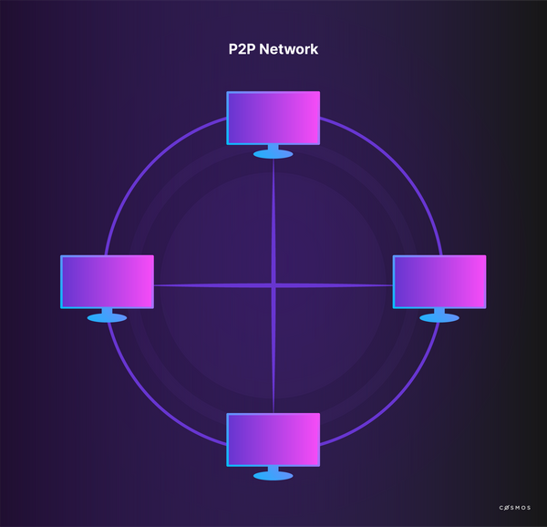

A public blockchain network has a few specific attributes:

* **Accessibility:** All you need to connect to Bitcoin or Ethereum is the client software and an internet connection. No AML, KYC, identity checks, or subscription payment is required.
* **No hierarchy:** All nodes are equal, meaning no individual node has more authority than another. All validators are also equal.
* **Crypto-economic incentives:** The lack of a central authority means there is no absolute defense against malicious behavior. Instead, the network usually incentivizes benevolent behavior and disincentivizes behavior that endangers the network functioning. It de facto implements prohibitive expenses to attack the network and others, and thus ensures security and proper function.
* **Full decentralization:** Many public networks are completely decentralized because they are non-hierarchical and fully accessible. The playing field for market participants is therefore relatively level, so traditional business models may not work as well.

The two most popular examples of functioning public networks are Bitcoin and Ethereum.

[#Copy link](https://ida.interchain.io/ida-course/0-blockchain-basics/3-managed.html#introduction-to-bitcoin) Introduction to Bitcoin

Since 2009, the most successful and popular decentralized public blockchain network has been Bitcoin. Nowadays, Bitcoin is the cryptocurrency with the highest market capitalization.



For an estimate of the Bitcoin network size, take a look at [Bitnodes (opens new window)↗](https://bitnodes.earn.com/). If you are more of a visual and statistics person, these [Bitcoin charts (opens new window)↗](https://www.blockchain.com/en/charts) are interesting.

Bitcoin was first introduced with the publication of the original paper [*Bitcoin: A peer-to-peer electronic cash system* (opens new window)↗](https://bitcoin.org/bitcoin.pdf) by Satoshi Nakamoto in 2008. In this paper, Nakamoto describes Bitcoin as a **peer-to-peer (P2P)** version of electronic cash. **Proof-of-work (PoW)** is proposed to establish the truth in a partially synchronous system without involving trusted parties. Using this method, the set of participants controlling the majority of the computing power determines the truth.

Let us look at this in more detail.

Nakamoto does not use the term "blockchain" in his paper, but describes the concept by explaining transactions in Bitcoin. The transaction process requires the signing of the transaction with the hash of the previous transaction and the public key of the receiver. This is called the chain of ownership. Transactions can contain several inputs and outputs.

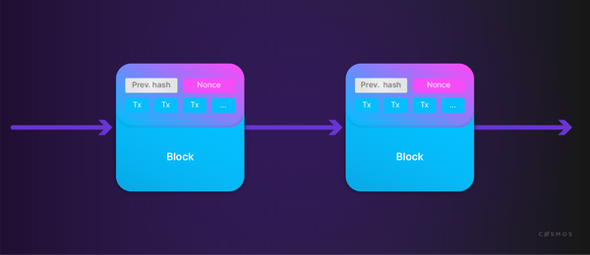

Each block includes the previous hash and a nonce, a random set of 1s and 0s. The protocol calls for a hash beginning with a specific number of binary 0s when hashing the block. Bitcoin uses a timestamp server to prevent double-spending. The block creator, called a **miner**, looks for a nonce which results in a block hash beginning with the right number of binary 0s. It is difficult to find a nonce that fulfills this condition, but it is easy to verify when one does.

The longest valid chain of blocks on the network is deemed the truth, because users recognise it contains proof of the most work, and it becomes exponentially more difficult to alter history as more blocks are appended. To promote an alternative version of history, an attacker must find a new nonce for the block they want to change **and** new nonces for *every subsequent block thereafter* to create a rival valid chain which is at least as long as that used by the consensus. This pits the attacker against the combined brute force (i.e. computing power) of the rest of the network.

There is a residual possibility that a slower attacker can catch up, since discovering a nonce works by evaluating random numbers and it is possible to make a fast lucky guess. However, this probability decreases exponentially as the number of blocks (a.k.a. confirmations) increases, so making changes to the "distant" past becomes progressively less practical.

The process of creating a valid block is called **mining** in PoW networks. The protocol includes a reward for mining, which is the first special transaction in the block. It can be expected that the majority of nodes use their CPU power honestly because this is the most financially feasible course of action. Signed transactions are announced publicly, so the public keys of the parties are not private.

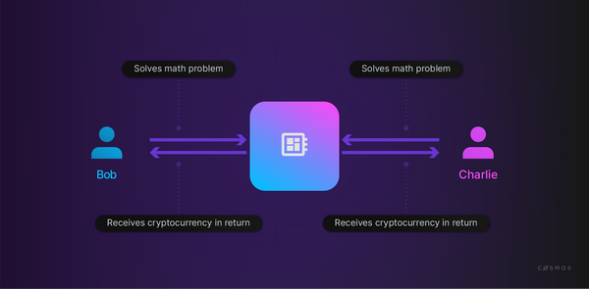

[#Copy link](https://ida.interchain.io/ida-course/0-blockchain-basics/3-managed.html#introduction-to-ethereum) Introduction to Ethereum

Ethereum is a public, blockchain-based, distributed computing platform and operating system with smart contract features. Ethereum emerged from a range of proposals rejected by the Bitcoin community.

The most important difference compared to Bitcoin is the implementation of distributed code execution through the **Ethereum Virtual Machine (EVM)**. The Ethereum network is a virtual state machine which enables the deployment of so-called **smart contracts** as part of the data of a transaction. The implementation of such a state machine with blockchain is revolutionary in itself.

The code execution platform is [Turing-complete (opens new window)↗](https://en.wikipedia.org/wiki/Turing_completeness). As part of Turing-completeness, frameworks must overcome the [halting problem (opens new window)↗](https://www.scientificamerican.com/article/why-is-turings-halting-pr/), which is especially difficult in distributed, hierarchy-free computing platforms.

In simple terms, the halting problem describes a scenario in which a program loops forever. Ethereum's solution is to introduce **Gas** as a fee for each computational step. Every block has a maximum Gas limit which limits the number of computational steps that can be executed per block - just like a combustion engine, if the Gas runs out then the program stops. Gas only exists during the execution of a transaction and the user is free to specify any **Gas price** in terms of **Ether**, a value which Ethereum requires to convert **Ether to Gas**.



**Ether** is the **native cryptocurrency** of the Ethereum platform, as Bitcoin is the native cryptocurrency of the Bitcoin blockchain.

The protocol defines the **Gas cost** for each operation in the EVM. The halting problem is resolved by attaching financial costs to every step in a program and by limiting the funds available. Transactions that do not compute successfully and are not on budget are rejected.

In Ethereum, **smart contracts** are stored on every single node - they are public. In practice, a smart contract in the EVM is an autonomous agent with an internal account. The most popular language for writing such a contract is **Solidity**.

Ethereum recently transitioned from Proof-of-Work to Proof-of-Stake consensus. Block times were unaffected by this change, by design, and are much faster - around 14 seconds at the time of writing.

The fact that Ethereum's virtual machine runs arbitrary programs hints at the potential of blockchain technology to disintermediate and decentralize processes which include network participants that would benefit from a shared set of facts and reliable interactions. The field of possibilities is expansive. It includes virtually all cases where trading partners need to reconcile their respective records, trade assets, and considerations in an atomic way, or to execute remedial actions such as penalties if a counterparty fails to deliver as agreed.

As promising as this sounds, the technology is **not without limitations**. Chief among these limitations is capacity, not only in terms of transactions per second but also in terms of the complexity of transactions that can be handled by the network. Ethereum's virtual machine paradigm places limits on transaction complexity to ensure that a single contract or a single transaction does not overload the shared, distributed computer. This constraint is inherent to the design choice of using a virtual machine model.

The Cosmos SDK enables the creation of application-specific blockchains. That is to say that Cosmos blockchains do not need smart contracts because application-level concerns are defined at the protocol level. This offers developers the possibility of enabling transactions with complexity far above what is possible on general-purpose blockchains. Because Cosmos chains can interact with other public networks like Ethereum through the Inter-Blockchain Communication Protocol (IBC), Cosmos blockchains can also be used to offload processes that are either too complex or too expensive to run on other networks.



Blockchain technology changes fast, but the basics are here to stay. This video provides a quick introduction to the concepts that underpin blockchain, including how data is encoded in transactions and added to a block, and how blocks and transactions spread through a network.

[#Copy link](https://ida.interchain.io/ida-course/0-blockchain-basics/3-managed.html#managed-blockchain-networks) Managed blockchain networks

Managed networks, just like public networks, rely on blockchain data structures. Unlike public blockchain networks, they do not necessarily need to mitigate the Byzantine Generals Problem because they operate in a predictable environment with elements of authority, hierarchy, and accountability.

Managed networks can be used in cases where elements of trust already exist between the participants. For example, consider a network of financial institutions. They could use blockchain technology to settle inter-bank transactions. In that case, there would be no need for public access; indeed, public access would be undesirable. Instead, they might consider a private network with each institution operating exactly one validator. All participants would understand that no operator in a single institution would be able to corrupt the network overall; however, it would be much easier for them *as a group* to alter a history if they found it detrimental, since it would only require the coordinated action of a small number of known validators.

Managed networks are typically governed through traditional governance processes that are appropriate for the shared goals of the participants.



Dive into the specifics of the Byzantine Generals Problem in the next section on [consensus in blockchain](https://ida.interchain.io/ida-course/0-blockchain-basics/4-consensus.html).

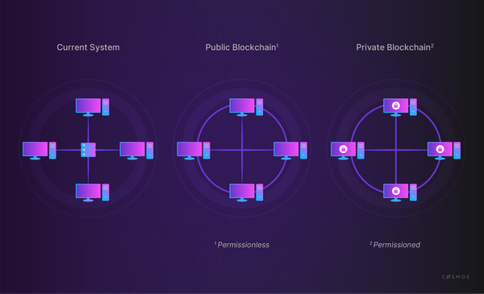

Public networks are based on game theory and economic incentives, which means that every action is probabilistic. There is no guarantee that a transaction will be picked up and even the integrity of the network is merely very likely, not 100% guaranteed.

This is often unacceptable, for example with traditional financial institutions. One of the biggest expenses financial and other institutions face is the operation and maintenance of infrastructure and the costs resulting from leaks, hacks, reconciliation with trading partners, errors, and data incompatibility. Blockchain seems like a promising solution.

Unlike public networks, where the interaction between participants is governed by the protocol and crypto-economic incentives, in managed networks the blockchain protocol is often a technical enforcement of pre-existing relationships and legally enforceable agreements.

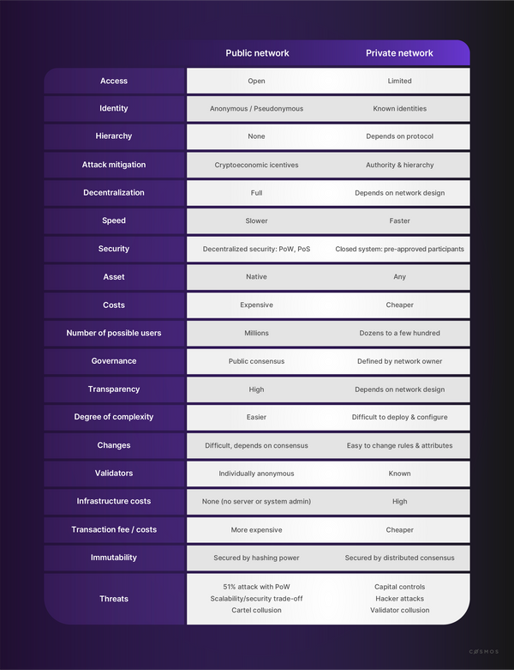

**Private blockchains** can be:

* **Designed for a limited number of vetted and approved participants:** performance challenges and poorly connected nodes are of lesser importance.
* **Designed for optimized performance:** most participants in an enterprise network are capable of running well-connected, high-performance, and high-availability nodes. A group of participants can agree to raise the bar defining minimum system requirements significantly.
* **Governed by a well-defined agreement between the participants:** such an agreement may codify the decision-making processes used to decide matters such as protocol upgrades, admission requirements, and remedial action. In a private or consortium setting, "who decides?" can (or likely *must*) be determined well in advance of any incident.

In summary, managed networks enable high-performance blockchain networks that can use consensus processes which are not suited for an environment with anonymous users. A group of trading partners can create a small network for their purposes and agree on equitable participation in the block-generation process (e.g. that each participant runs one validator), minimum performance metrics for acceptable validators, and governance, all of which enable fast confirmation and even deterministic transaction finality within their small group. The principal trade-off for this performance improvement is the shunning of permissionless, public access.

Cosmos can be applied to both public and private settings and, importantly, supports communication between networks following different consensus rules, a seemingly intractable challenge for the predecessors of Cosmos.



**Further readings**

* [Buterin, Vitalik (2014): A Next-Generation Smart Contract and Decentralized Application Platform - The Ethereum White Paper (opens new window)↗](https://github.com/ethereum/wiki/wiki/White-Paper)
* [Nakamoto, S. (2008): Bitcoin: A Peer-to-Peer Electronic Cash System (opens new window)↗](https://bitcoin.org/bitcoin.pdf)
* [Vitalik Buterin on private chains (opens new window)↗](https://blog.ethereum.org/2015/08/07/on-public-and-private-blockchains)
* [Permissioned blockchains in production (opens new window)↗](https://www.multichain.com/blog/2017/11/three-non-pointless-blockchains-production/)

synopsis

To summarize, this section has explored:

* How *public* blockchain networks tend to emphasize the characteristics of *accessibility*, *the absence of hierarchy*, *full decentralization*, and the use of *crypto-economic incentives*. They are based on game theory and economic rewards and are probabilistic in nature, so they cannot absolutely guarantee transaction inclusion or event network integrity, which makes them problematic for some traditional institutions.
* How *managed* blockchain networks offer an alternative as they do not necessarily need to mitigate the Byzantine Generals Problem, because they operate in predictable environments with elements of authority, hierarchy, and accountability. They often embrace traditional governance processes appropriate to the shared goals of the participants.
* How **Bitcoin** extends its record of network activity by rewarding independent "miner" nodes for grouping new transactions into blocks with particular characteristics that require much work to achieve but little work to verify. These blocks are constructed into a chain such that any alteration of data is easily identifiable, and any deliberate manipulation of the historical record would require unfeasible efforts on the part of an attacker to achieve.
* How the **Ethereum** network provides a revolutionary blockchain-based, Turing-complete virtual state machine (the EVM), delivering a computing platform and operating system with smart contract features. To avoid the halting problem, in which programs become stuck in an endless loop, Ethereum introduced the notion of charging a fee for each computational step, meaning that programs with insufficient "gas" to complete will simply stop, releasing the EVM to work on other programs.
* How Bitcoin and Ethereum handle **forking**, the possibility of rival chains spreading through the network: Bitcoin's long 10 minute block times reduces the probability of transient forks from occurring; Ethereum's 15 *second* block time makes rival blocks more likely, but instead of discarding them as the longest canonical chain extends they are added to it as "uncles", increasing the amount of work that would be required to undermine the chain, and therefore increasing its overall security.
* How Cosmos moves past the example set by Ethereum to offer developers an ecosystem capable of platforming smart contracts or dApps *individually*, as opposed to forcing them to share and conform to the technological constraints of the single Ethereum blockchain. It can satisfy the demands of both public and private blockchains, and also supports communications between networks even if they follow differing consensus rules.

previous

[](https://ida.interchain.io/ida-course/0-blockchain-basics/2-public.html)

**[Blockchain History](https://ida.interchain.io/ida-course/0-blockchain-basics/2-public.html)**

up next

**[Consensus in Distributed Networks](https://ida.interchain.io/ida-course/0-blockchain-basics/4-consensus.html)**

[[](https://ida.interchain.io/ida-course/0-blockchain-basics/4-consensus.html)](https://ida.interchain.io/ida-course/0-blockchain-basics/4-consensus.html)

Rate this Page

icon smile

icon meh

icon frown

Would you like to add a message?

Submit

Thank you for your Feedback!

On this page

[Introduction to Bitcoin](https://ida.interchain.io/ida-course/0-blockchain-basics/3-managed.html#introduction-to-bitcoin)

[Introduction to Ethereum](https://ida.interchain.io/ida-course/0-blockchain-basics/3-managed.html#introduction-to-ethereum)

[Managed blockchain networks](https://ida.interchain.io/ida-course/0-blockchain-basics/3-managed.html#managed-blockchain-networks)

#### **Get Cosmos updates**

Unsubscribe at any time. [Privacy Policy↗](https://v1.cosmos.network/privacy)

     Next

Documentation

[Cosmos SDK](https://docs.cosmos.network/)[Cosmos Hub](https://hub.cosmos.network/)[CometBFT](https://docs.cometbft.com/)[IBC Protocol](https://ibc.cosmos.network/)

Community

[Interchain blog](https://blog.cosmos.network/)[Forum](https://forum.cosmos.network/)[Discord](https://discord.gg/cosmosnetwork)

Contributing

[Source code on GitHub](https://github.com/cosmos/sdk-tutorials)

[](https://ida.interchain.io/)

[Interchain Developer Academy](https://ida.interchain.io/)

**[](https://blog.cosmos.network/)[](https://twitter.com/cosmos)[](https://discord.gg/cosmosnetwork)[](https://www.linkedin.com/company/interchain-foundation/about/)[](https://reddit.com/r/cosmosnetwork)[](https://t.me/cosmosproject)[](https://www.youtube.com/c/CosmosProject)**



Dark mode

† This website is maintained by the Interchain Foundation (ICF). The contents and opinions of this website are those of the ICF. The ICF provides links to cryptocurrency exchanges as a service to the public. The ICF does not warrant that the information provided by these websites is correct, complete, and up-to-date. The ICF is not responsible for their content and expressly rejects any liability for damages of any kind resulting from the use, reference to, or reliance on any information contained within these websites.

Cosmos is a registered trademark of the [Interchain Foundation.](https://interchain.io/)[Privacy](https://v1.cosmos.network/privacy)